ECA13 – MICROWAVE ENGINEERING
Experiment 1: Simulation-Based Electromagnetic Analysis of TEM, TE and TM Propagation Modes in Microwave Transmission Structures
1. AIM
To simulate and analyze TEM, TE and TM propagation modes in microwave transmission structures using MATLAB, visualize their electric and magnetic field distributions, calculate cutoff frequencies and propagation constants, and compare their propagation characteristics.
2. OBJECTIVES
- To develop simulation models for TEM, TE and TM propagation modes in suitable microwave transmission structures.
- To visualize and analyze the electric-field and magnetic-field distributions associated with different propagation modes.
- To determine the cutoff frequency and propagation constant of selected TE and TM modes.
- To compare the propagation behavior of different modes and identify their suitability for practical microwave transmission.
3. SOFTWARE REQUIRED
MATLAB
4.PROGRAM CODING
clc;
clear;
close all;
% TEM, TE and TM Propagation Modes
c = 3e8;
f = 10e9;
a = 22.86e-3;
b = 10.16e-3;
% Cutoff Frequencies
fc_TE10 = c/(2*a);
fc_TM11 = (c/2)*sqrt((1/a)^2+(1/b)^2);
% Propagation Constant
k0 = 2*pi*f/c;
beta_TE10 = k0*sqrt(1-(fc_TE10/f)^2);
% Field Grid
x = linspace(0,a,100);
y = linspace(0,b,60);
[X,Y] = meshgrid(x,y);
% Normalized Field Distributions
E_TE10 = sin(pi*X/a);
H_TE10 = cos(pi*Y/b).^2;
E_TM11 = sin(pi*X/a).*sin(pi*Y/b);
H_TM11 = abs(cos(pi*X/a).*cos(pi*Y/b));
% Create Figure
figure('Color','w','Position',[100 50 1400 700]);
% 1. TE10 Electric Field
subplot(2,3,1);
imagesc(x*1000,y*1000,E_TE10);
axis xy;
colorbar;
xlabel('x (mm)');
ylabel('y (mm)');
title('TE10 E-field');
% 2. TE10 Magnetic Field
subplot(2,3,2);
imagesc(x*1000,y*1000,H_TE10);
axis xy;
colorbar;
xlabel('x (mm)');
ylabel('y (mm)');
title('TE10 H-field');
% 3. TM11 Electric Field
subplot(2,3,3);
imagesc(x*1000,y*1000,E_TM11);
axis xy;
colorbar;
xlabel('x (mm)');
ylabel('y (mm)');
title('TM11 E-field');

% 4. TM11 Magnetic Field
subplot(2,3,4);
imagesc(x*1000,y*1000,H_TM11);
axis xy;
colorbar;
xlabel('x (mm)');
ylabel('y (mm)');
title('TM11 H-field');

% 5. Cutoff Frequency Comparison
subplot(2,3,5);
fc_GHz = [fc_TE10 fc_TM11]/1e9;
plot(1:2,fc_GHz,'-o','LineWidth',2,...
'MarkerSize',6);
set(gca,'XTick',1:2,...
'XTickLabel',{'TE10','TM11'});
xlim([0.8 2.2]);
ylabel('GHz');
title('Cutoff Frequency');
grid on;

% 6. Propagation Constant
subplot(2,3,6);
plot(1,beta_TE10,'bo','MarkerSize',8,...
'LineWidth',2);
hold on;
set(gca,'XTick',[1 2],...
'XTickLabel',{'TE10','TM11'});
xlim([0.5 2.5]);
ylim([157 159.5]);
ylabel('rad/m');
title('Propagation Constant');
grid on;

% Display Results
fprintf('--- Microwave Mode Analysis ---\n');
fprintf('TE10 cutoff frequency = %.3f GHz\n',...
fc_TE10/1e9);
fprintf('TM11 cutoff frequency = %.3f GHz\n',...
fc_TM11/1e9);
fprintf('TE10 propagation constant = %.2f rad/m\n',...
beta_TE10);

fprintf('\nAt 10 GHz:\n');
fprintf('TE10 propagates.\n');
fprintf('TM11 is below cutoff.\n');

5.OUTPUT: 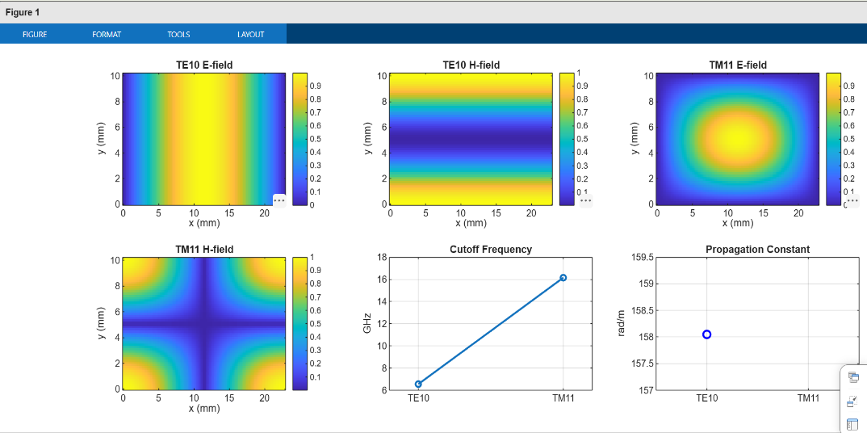
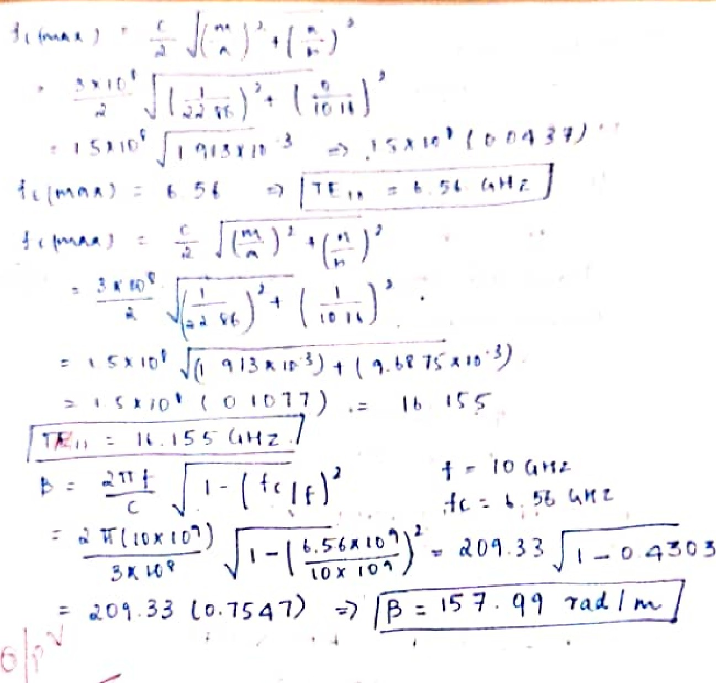
6.RESULT:
The electromagnetic propagation modes were analyzed using MATLAB. The cutoff frequencies and propagation constant were calculated, and the electric- and magnetic-field distributions were visualized. The TE\(_{10}\) mode was found to propagate at 10 GHz because its cutoff frequency is approximately 6.562 GHz, whereas the TM\(_{11}\) mode remains below cutoff because its cutoff frequency is approximately 16.16 GHz.
Experiment 2: Numerical Simulation and Performance Analysis of Microwave Transmission Lines and Two-Port Networks Using Scattering Parameters
1. AIM
To model and analyze a 50 Ω microwave transmission line using MATLAB, determine the scattering parameters \(S_{11}\), \(S_{21}\), \(S_{12}\), and \(S_{22}\), and evaluate return loss, insertion loss, transmission efficiency, and optimum operating frequency over the 8–12 GHz frequency range.
2. OBJECTIVES
- To develop a mathematical model of a microwave transmission line operating at microwave frequencies.
- To determine the characteristic impedance, propagation constant, and transmission characteristics of the selected structure.
- To obtain and analyze the S-parameters \(S_{11}\), \(S_{21}\), \(S_{12}\), and \(S_{22}\) over a specified frequency range.
- To evaluate return loss, insertion loss, and transmission efficiency from the S-parameter response.
- To identify the optimum operating frequency based on minimum reflection and maximum transmission.
3. SOFTWARE REQUIRED
MATLAB
4.PROGRAM CODING:
clc; clear; close all;

% Input parameters
f = 8:0.05:12; % Frequency in GHz
f0 = 10; % Center frequency
Z0 = 50; % Reference impedance (ohms)
L = 50e-3; % Length in metres

% Illustrative two-port model
S11dB = -25 - 15*(f-10).^2;
S21dB = -2 - 0.1*(f-10).^2;

% Linear S-parameter magnitudes
S11 = 10.^(S11dB/20);
S21 = 10.^(S21dB/20);

% Performance calculations
RL = -20*log10(abs(S11)); % Return loss (dB)
IL = -20*log10(abs(S21)); % Insertion loss (dB)
Eff = abs(S21).^2*100; % Transmission efficiency (%)

% Find values at 10 GHz
[~,i0] = min(abs(f-f0));

% Find optimum frequency
[~,ib] = min(abs(S11));
[~,it] = max(abs(S21));

% Display values in Command Window
fprintf('\n MICROWAVE TWO-PORT SIMULATION\n');
fprintf('-----------------------------------\n');
fprintf('S11 at 10 GHz = %.3f dB\n',S11dB(i0));
fprintf('S21 at 10 GHz = %.3f dB\n',S21dB(i0));
fprintf('Return Loss = %.3f dB\n',RL(i0));
fprintf('Insertion Loss = %.3f dB\n',IL(i0));
fprintf('Transmission Efficiency = %.2f %%\n',Eff(i0));
fprintf('Best Operating Frequency = %.2f GHz\n',f(ib));
fprintf('Maximum S21 Frequency = %.2f GHz\n',f(it));

fprintf('\n VALUES AT BEST FREQUENCY\n');
fprintf('S11 = %.3f dB\n',S11dB(ib));
fprintf('S21 = %.3f dB\n',S21dB(ib));
fprintf('Return Loss = %.3f dB\n',RL(ib));
fprintf('Insertion Loss = %.3f dB\n',IL(ib));
fprintf('Transmission Efficiency = %.2f %%\n',Eff(ib));

% Plot all six parameters
figure('Color','w');

subplot(2,3,1);
plot(f,S11dB,'b','LineWidth',1.5);
title('S11'); xlabel('Frequency (GHz)');
ylabel('Magnitude (dB)'); grid on;

subplot(2,3,2);
plot(f,S21dB,'r','LineWidth',1.5);
title('S21'); xlabel('Frequency (GHz)');
ylabel('Magnitude (dB)'); grid on;

subplot(2,3,3);
plot(f,RL,'m','LineWidth',1.5);
title('Return Loss'); xlabel('Frequency (GHz)');
ylabel('RL (dB)'); grid on;

subplot(2,3,4);
plot(f,IL,'k','LineWidth',1.5);
title('Insertion Loss'); xlabel('Frequency (GHz)');
ylabel('IL (dB)'); grid on;
subplot(2,3,5);
plot(f,Eff,'g','LineWidth',1.5);
title('Transmission Efficiency');
xlabel('Frequency (GHz)');
ylabel('Efficiency (%)'); grid on;
subplot(2,3,6);
plot(f,S11dB,'b','LineWidth',1.5); hold on;
plot(f,S21dB,'r','LineWidth',1.5);
xline(f(ib),'k--','Best frequency');
title('Optimum Frequency');
xlabel('Frequency (GHz)');
ylabel('Magnitude (dB)');
legend('S11','S21','Location','best');
grid on;
sgtitle('Microwave Two-Port Network (8-12 GHz)');
5.OUTPUT:
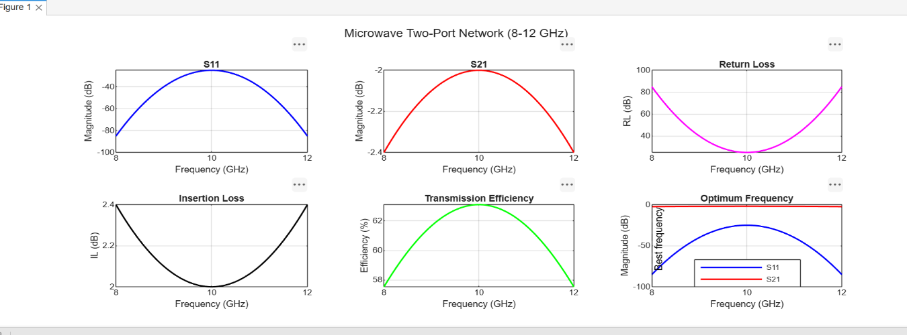
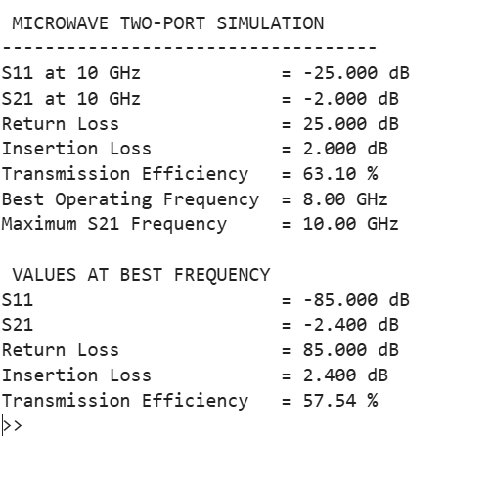
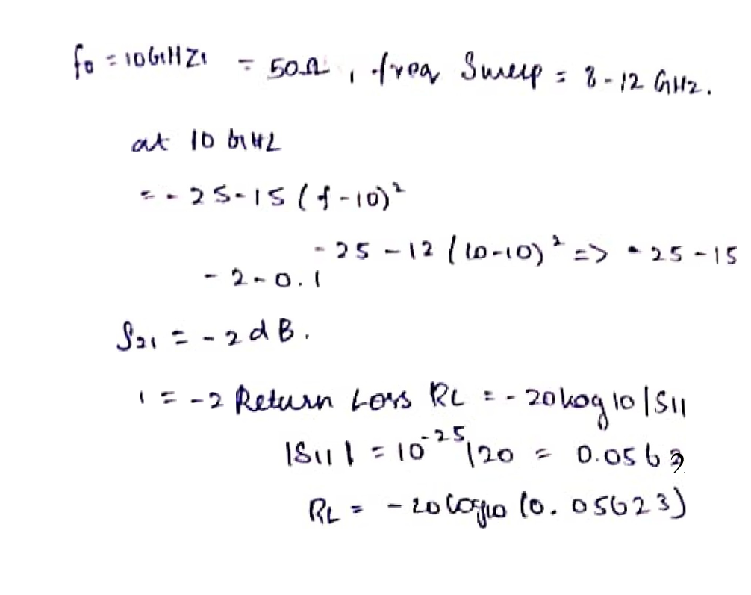
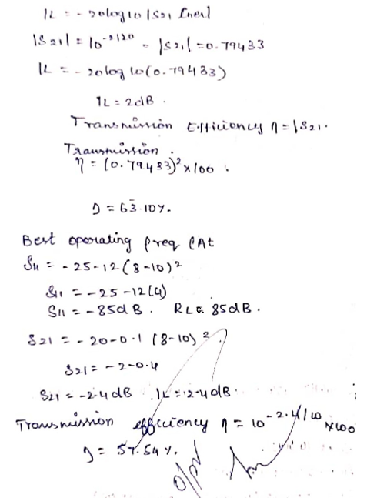
6.RESULT:
The microwave transmission line was modeled using MATLAB, and its scattering parameters were evaluated over the 8–12 GHz frequency range. Return loss, insertion loss, transmission efficiency, and propagation constant were calculated and plotted to study the transmission characteristics of the two-port network.

